***St. Joseph’s Church, O’Connell Avenue, Limerick***

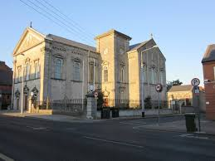

***Church Notices23rd January 2022***

Sun 23rd January ***10.30am*** –Jimmy McKillican *(5th Av)*

***10.30am*** –Michael Holmes *(1st Av)*

***10.30am*** –Stephen Cleary *(1st Av)*

***10.30am*** –John *(Av)* & Mary Bowman

***12.30pm*** –Paddy Chawke *(10th Av)*

***12.30pm*** –Eileen Moloney *(2nd Av)*

***12.30pm*** –Patsy McMahon nee Mulqueen

***12.30pm*** –Ann O’Gorman who died recently

***5.30pm*** – Margaret & Bill Hoare *(Av’s)*

***5.30pm*** –Trudy Kiely *(Month’s Mind)*

***5.30pm*** –Joseph McCarthy *(36th Av)*

Mon 24th January ***10.30am*** *–* Michael & Delia O’Shea

Tues 25th January ***10.30am*** – Brendan Lewis *(Recently Deceased)*

Wed 26th January ***10.30am*** – Saoirse Corrigan *(Recently Deceased)*

Thurs 27th January ***10.30am*** *–* Maura O’Regan *(Birthday Remembrance)*

Fri 28th January ***10.30am –*** Albert (Av), Mai & Bryan Walsh

Sat 29th January ***10.30am*** – *Pro Populo*

Sun 30th January***10.30am*** – *Intention of Clergy*

***12.30pm*** –Darren O’Donovan *(6th Av)*

***5.30pm*** – *Intention of Clergy*

**RECENT BAPTISM**

As a faith community we welcome and congratulate Perri Jordan Daly, daughter of Ciara & Edward. We pray that the Lord will journey with her always.

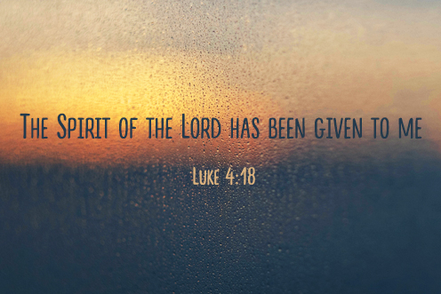

**YEARLY DONATION BOX OF ENVELOPES**

The new box of envelopes for the coming year will be distributed in the coming weeks. If you would like to receive a box for your donation to St. Joseph’s Parish, please make contact with either Úna or Fr. Liam. Thank you

**CALLING NEW MINISTERS FOR OUR CHURCH**

We would like to invite you to consider becoming a Reader or Eucharistic Minister in our Parish Church. Please take time to consider volunteering just a little time in the service of the church and in the celebration of our liturgies. Training for Eucharistic ministers and readers is being organised in the near future so get in touch with Úna or Fr. Liam if you are interested. Thank you

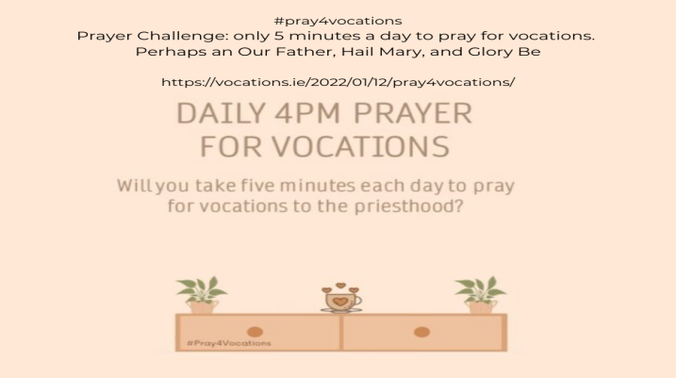

**LIVE-STREAMING**

We are now live-streaming our services from St. Joseph’s Church. All you need to do is to visit our parish website ***stjosephsparish.ie*** and click on the web-cam option. We would also ask you to please consider making a donation on line for the upkeep of our beautiful church.

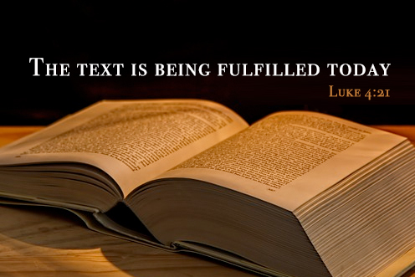

**THANK YOU**

I would like to sincerely thank everyone who contributed to the Christmas dues collection. Your donation is greatly appreciated and goes towards the salary of the priests working here in St. Joseph’s Parish. Úna would also like to thank all those who donated to the Parish Clerk’s Collection at Christmas. Your donation goes a long way in thanking her for all that she does in our church and for our parish.

**We would continue to ask that parishioners and visitors would consider maintaining a sensible distance, in so much as one can, from each other. If you are feeling unwell, we would kindly ask that you follow the HSE guidelines and remain at home until you are back to good health. We must also ask that everyone who attends St. Joseph’s Church must wear a mask until otherwise instructed. Thank you.**

|  |  |  |
| --- | --- | --- |
| |  |  | | --- | --- | | |  | | --- | |  | | |
| |  |  | | --- | --- | | |  | | --- | |  | | |

**Contact Details: Fr. Liam Enright 087-7415603, Sacristan: Úna McCarthy 061-313401**

***Email:***[*stjosephsparishlk@eircom.net*](mailto:stjosephsparishlk@eircom.net)***Website:*** *stjosephsparish.ie*